**SIR APOLLO**

**END OF TERM III EXAMINATION 2023**

**PRIMARY ONE**

**LITERACY 1A**

**My name is ___________________________________________**

**I am in ________________________________________________**

**My school is __________________________________________**

**SECTION A**

1. Name the non-living thing below.

_____________________________

2. Name any **one** thing used to keep the body clean.

__________________________________________________________________

3. Give **one** example of a plant.

__________________________________________________________________

4. How many senses do you have?

__________________________________________________________________

5. Write any **one** garden tool.

___________________________________________________________________

6. What do we call a person who has got an accident?

___________________________________________________________________

**(sick a casualty)**

7. What name is given to animals that stay in the bush?

___________________________________________________________________

8. Which insect provides people with honey?

____________________________________________________________________

9. **Name the item below**;

**_____________________________ ( first aid box , flask)**

10. What does a bird use for flying?

________________________________________________ **( legs , wings)**

11. **Tick one way of keeping food safe.**

By smokingByputting it in the pot.

12. Circle the common disease at school.

Malaria Ebola

13. How do we keep our classrooms clean?

_________________________________________________________________

14. Mention any **one** container used to keep water.

__________________________________________________________________

15. Give the **use** of the garden tool below.

___________________________________________

16. **Name the body part below**.

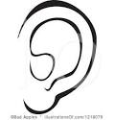

___________________________

17. A baby is to man as __________________________ is to a pig.

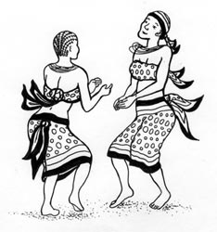18. **Name the body exercise below**.

**____________________________________**

19. **Name the dangerous object below**.

___________________________________________________

20. **What is she suffering from?**

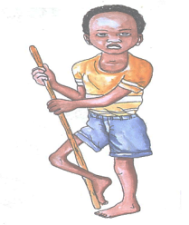

___________________________________________

**SECTION B**

21. a) Write down **two** domestic animals.

i)__________________________ ii)_________________________________

b) What name is given to the young one of a goat?

__________________________________________________________________

c) Which animal lives in a sty?

__________________________________________________________________

22. a) **Name this food we get from water**.

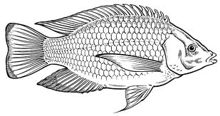

__________________________________________

b) **Tick three ways of preserving food.**

- by smoking

- to save life

- by salting

- to be healthy

- by canning

23. a) What do we call a person who gives first aid?

____________________________________ **( casualty , first aider)**

b) **Circle the common accidents at home.**

cuts , cats , burns , nails , fracture , spirit

24. a) Why do we brush our teeth?

_________________________________________________________________

b) Write any **three** items used to keep the body clean.

i)______________________ ii)____________________ iii)_________________

25. **Draw these things used to clean the body**.

|  |  |  |  |
| --- | --- | --- | --- |
| sponge | soap | water | toothbrush |
|  |  |  |  |

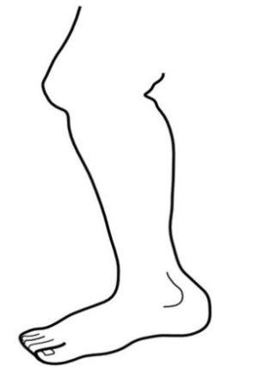26. **Name the parts of the leg**.

**a a ______________________**

**b b ______________________**

**c** ______________________

**d** ______________________

**c**

**d**

**( ankle , toes , calf , knee)**

27. **Tick four effects of accidents**.

death animals

Blindness dumbness

Thorns lameness

28. **Name the types of weather.**

|  |  |  |  |
| --- | --- | --- | --- |
| **ANd9GcQ1p2koWf4sJ9OivxPYmbnJL7lpDXR-x3LTS4TYILFZMMIYUpQ1** | **windy.jpg** | **MC900432591[1]** | **j0293828** |
|  |  |  |  |

**END**